A000-Afr-Mali-Dogon-Bandigara Cliffs-Tellem male figure–Sandstone-19th c

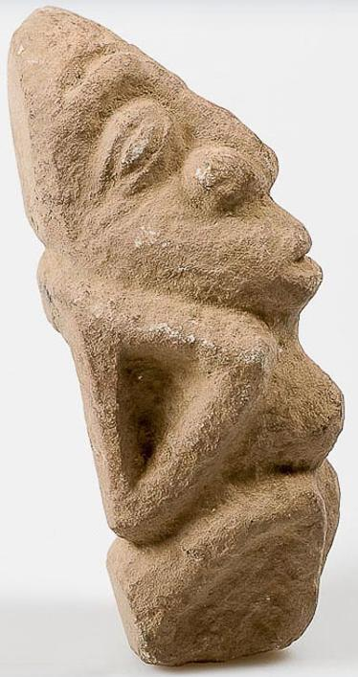

Tellem sandstone figure of a crouching male, Bandiagara cliffs, Mali.

**Case no.:**

**Accession Number:**

**Formal Label:**

**Display Description:**

This figurine was carved during a period of drought corresponding to the Little Ice Age (ca. 1250-1700 CE). The reverential posture was intended to pacify the spirits for more rain, better crops and freedom from disease

**LC Classification:**

**Date or Time Horizon:**

**Geographical Area:**

**Map:**

**GPS coordinates:**

**Cultural Affiliation:**

**Media:**

**Dimensions:**

**Weight:**

**Condition:**

**Provenance:**

**Discussion:**

It was during this period when the Black Death invaded Europe (1347-1350 CE)

**References:**

* Tellem sandstone figure of a crouching male, Bandiagara cliffs, Mali.
* During a period of drought corresponding to the Little Ice Age (ca. 1250-1700 CE)
* The reverential posture was intended to pacify the spirits for more rain, better crops and freedom from disease.
* It was during this period when the Black Death invaded Europe (1347-1350 CE)